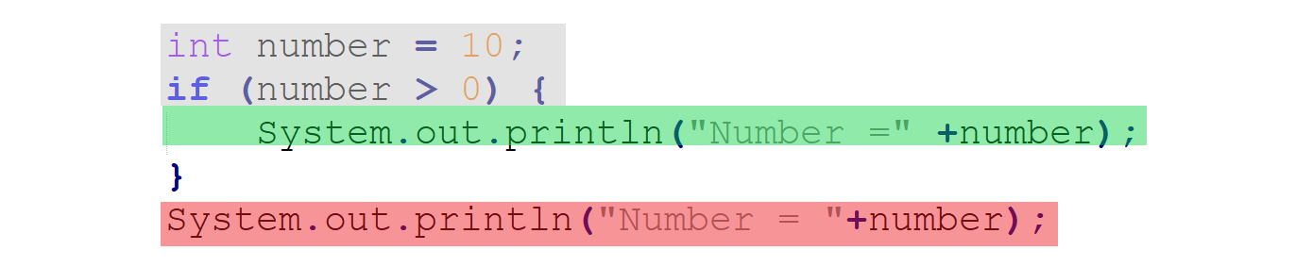

a. grey, red

b. green, red

c. grey, green, red

d. grey, green

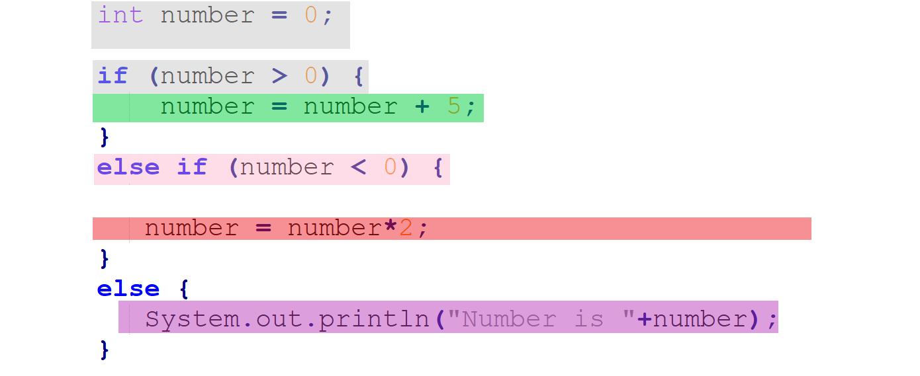

a. grey, purple

b. grey, green, purple

c. grey, green

d. grey, pink, purple

After the code executes what is the value of number?

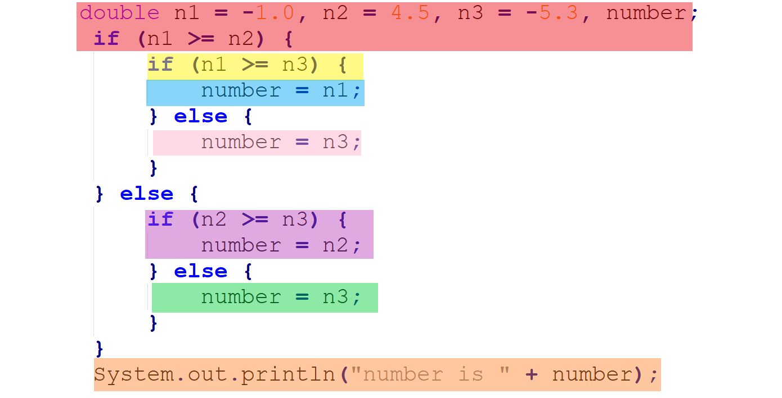

a. red, purple, orange

b. red, yellow, pink, orange

c. red, purple, orange

d. red, orange

After the code executes what is the value of number?­